1.50: Method 1: 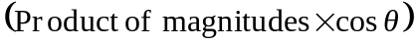
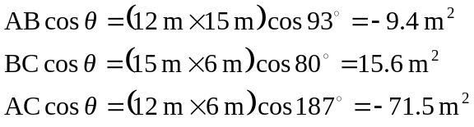

Method 2: (Sum of products of components)
